**Algorithm Analysis:**

Green – Goal node

Yellow – Start node

Blue – Expanded node

Red – Shortest path

**A* implementation:**

Hard maze:

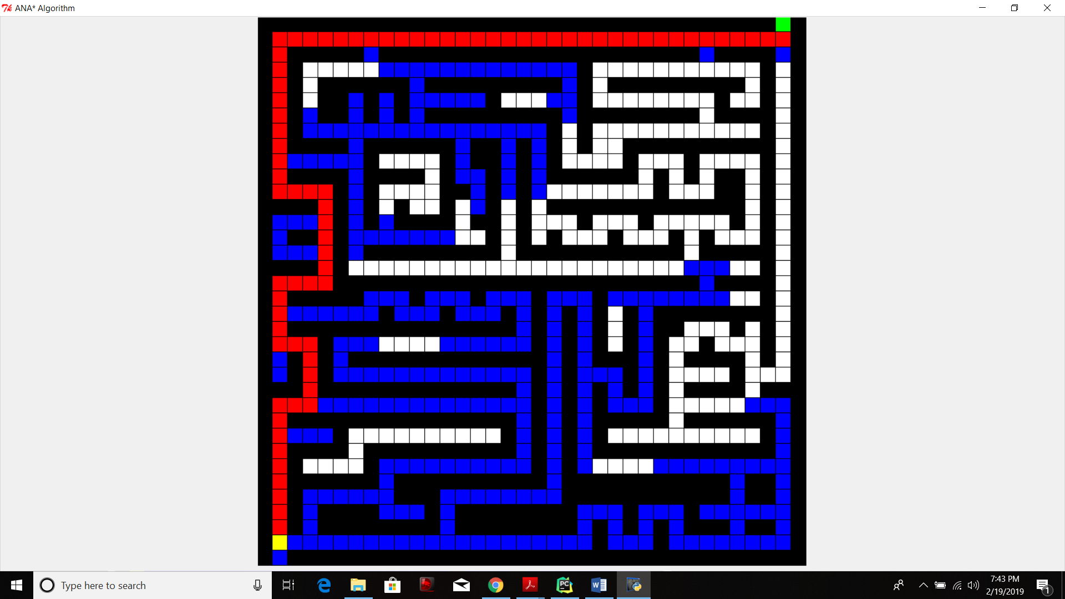

Time_taken for Astar:

0.556598234694

Shortest path:

[(0, 34), (1, 34), (1, 33), (1, 32), (1, 31), (1, 30), (1, 29), (1, 28), (1, 27), (1, 26), (1, 25), (1, 24), (1, 23), (1, 22), (1, 21), (1, 20), (1, 19), (1, 18), (1, 17), (1, 16), (1, 15), (1, 14), (1, 13), (1, 12), (1, 11), (1, 10), (1, 9), (1, 8), (1, 7), (1, 6), (1, 5), (1, 4), (1, 3), (1, 2), (1, 1), (2, 1), (3, 1), (4, 1), (5, 1), (6, 1), (7, 1), (8, 1), (9, 1), (10, 1), (11, 1), (11, 2), (11, 3), (11, 4), (12, 4), (13, 4), (14, 4), (15, 4), (16, 4), (17, 4), (17, 3), (17, 2), (17, 1), (18, 1), (19, 1), (20, 1), (21, 1), (21, 2), (21, 3), (22, 3), (23, 3), (24, 3), (25, 3), (25, 2), (25, 1), (26, 1), (27, 1), (28, 1), (29, 1), (30, 1), (31, 1), (32, 1), (33, 1), (34, 1)]

Length of astar solution

78

Easy Maze:

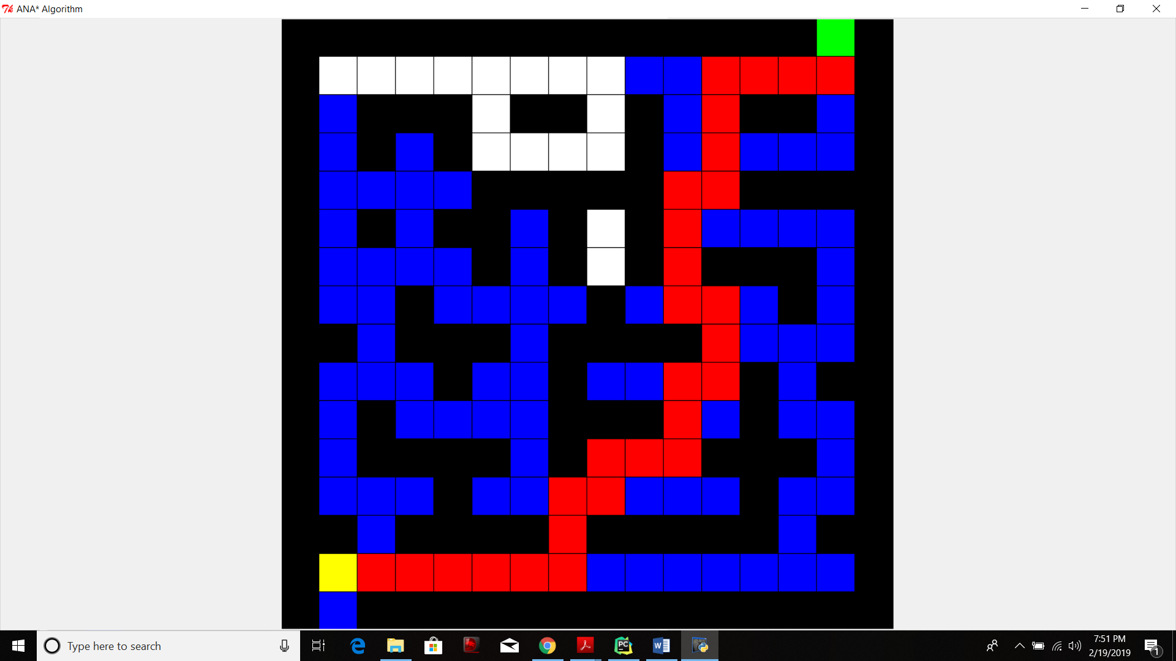

Time_taken for Astar

0.401823653229

Shortest path:

[(0, 14), (1, 14), (1, 13), (1, 12), (1, 11), (2, 11), (3, 11), (4, 11), (4, 10), (5, 10), (6, 10), (7, 10), (7, 11), (8, 11), (9, 11), (9, 10), (10, 10), (11, 10), (11, 9), (11, 8), (12, 8), (12, 7), (13, 7), (14, 7), (14, 6), (14, 5), (14, 4), (14, 3), (14, 2), (14, 1)]

Length of astar solution:

30

ANA star implementation: